Chrome dev Commands
Debugging java script tool :
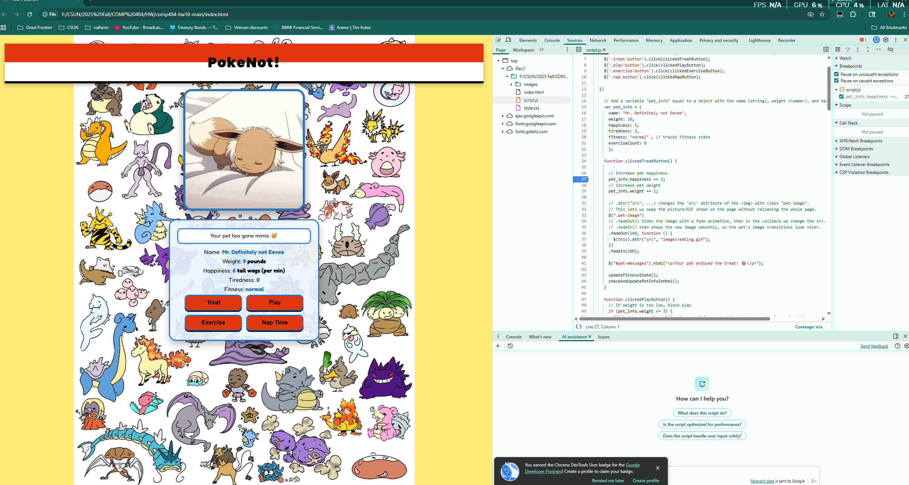
- Here I just open the dev tools on my current page
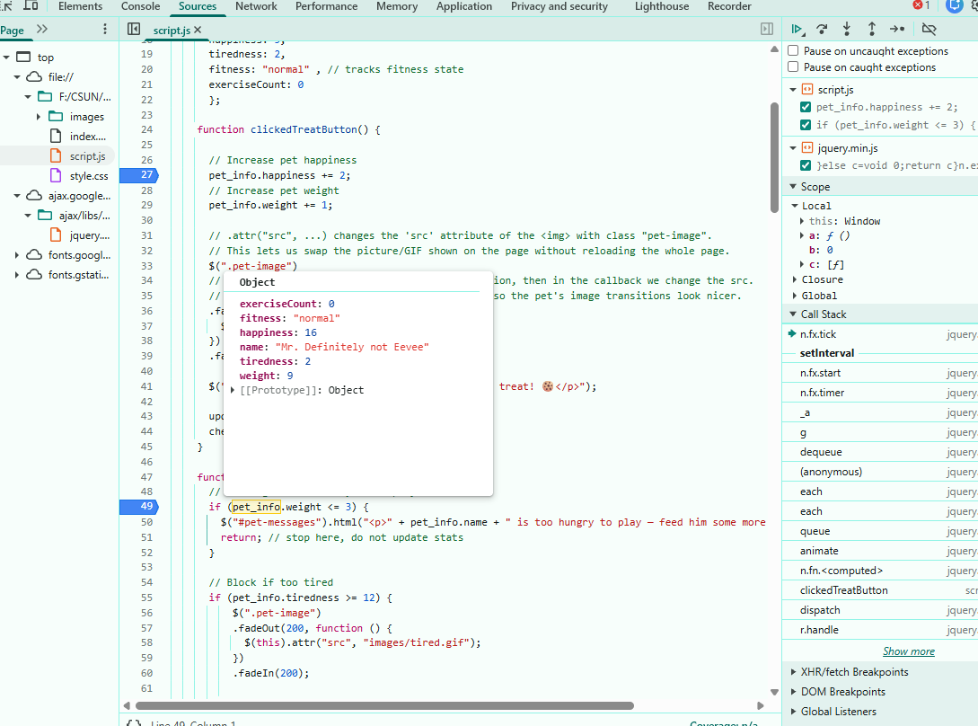
- here you can see the pet info that will be updated when the button is clicked
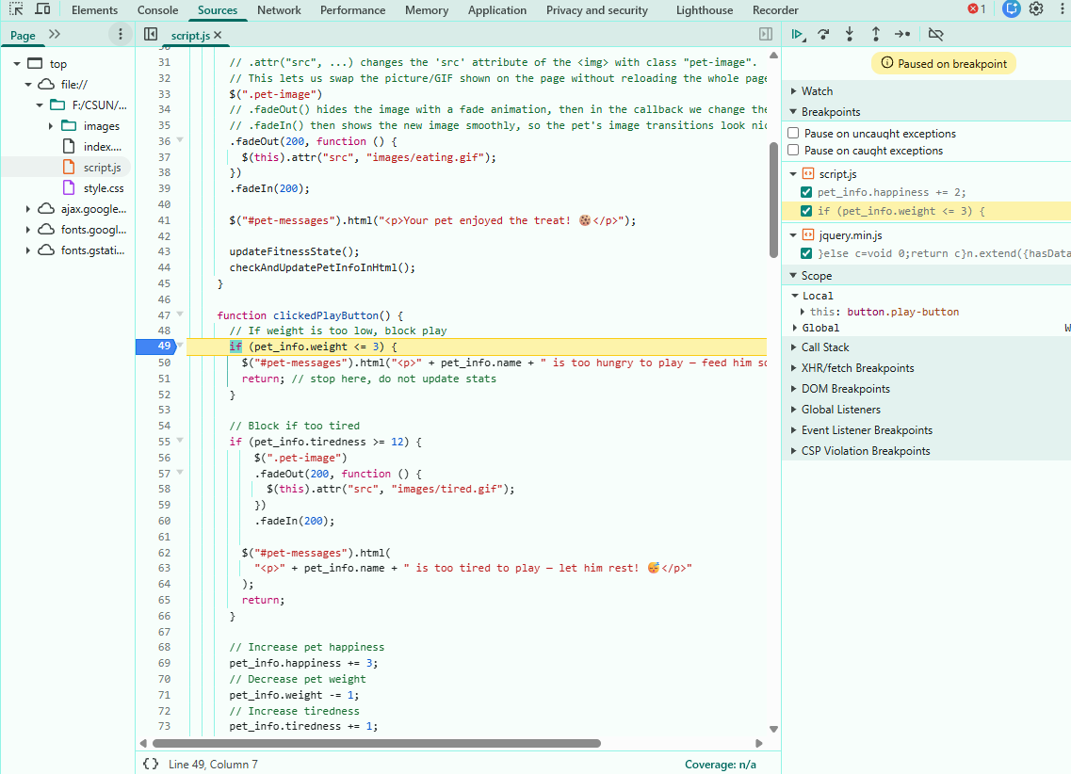
- here I selected the breakpoint to be the if statement

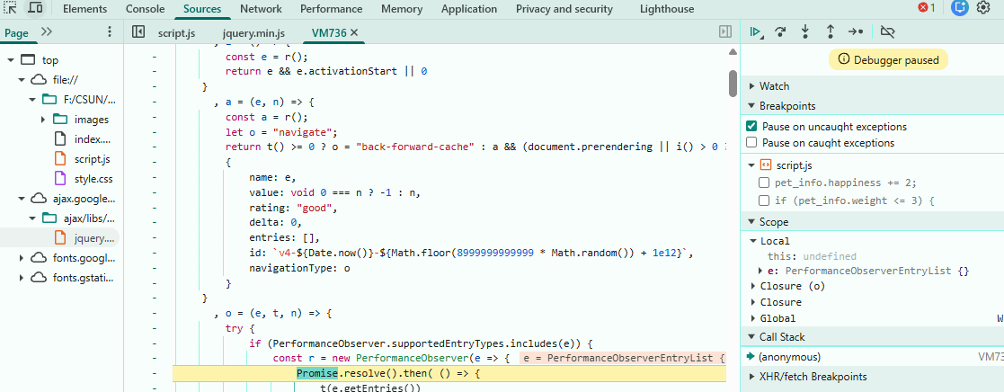
- here I noticed that it was pausing on the jquery code rather than my own code

DOM:
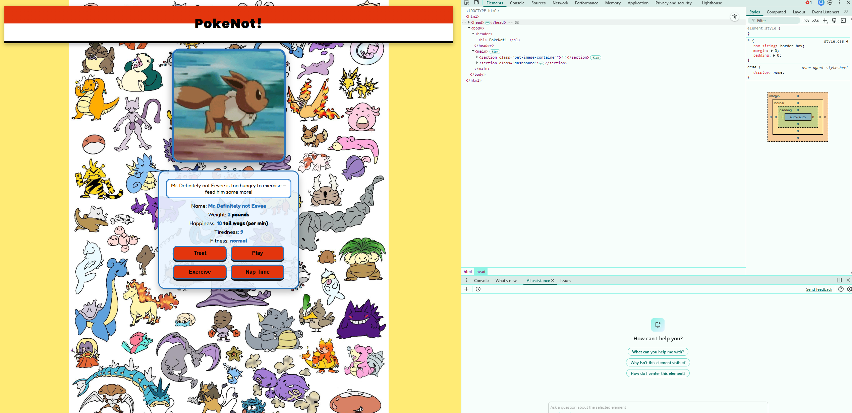
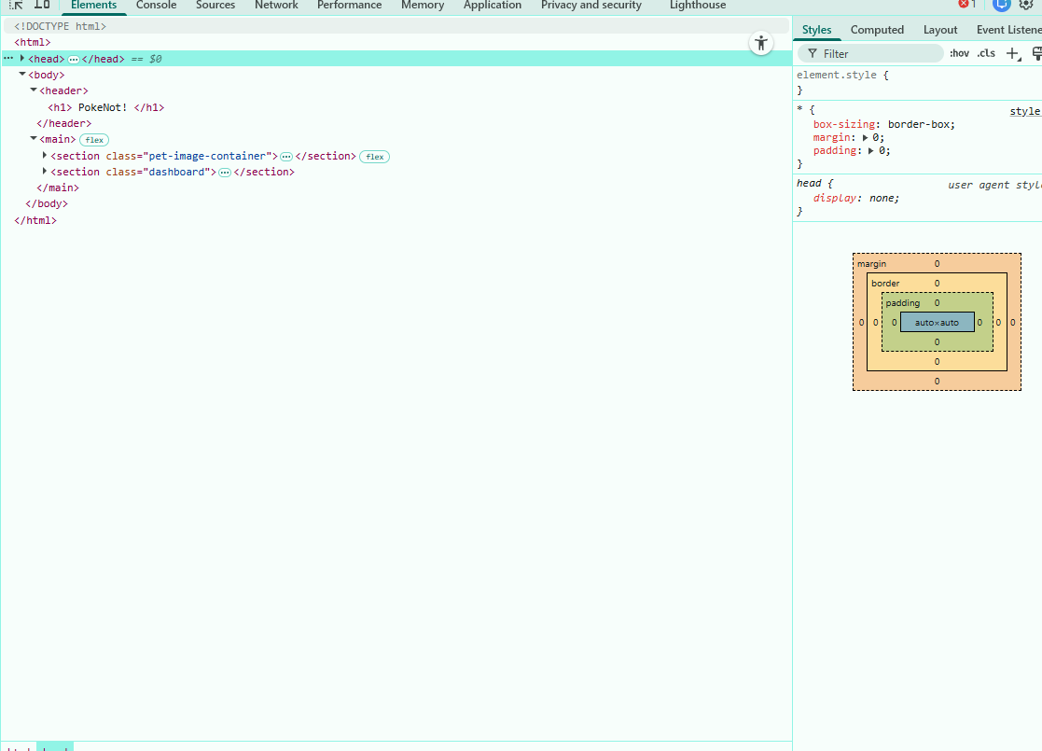
- here I took a sc of the dom tree that is going over the html page

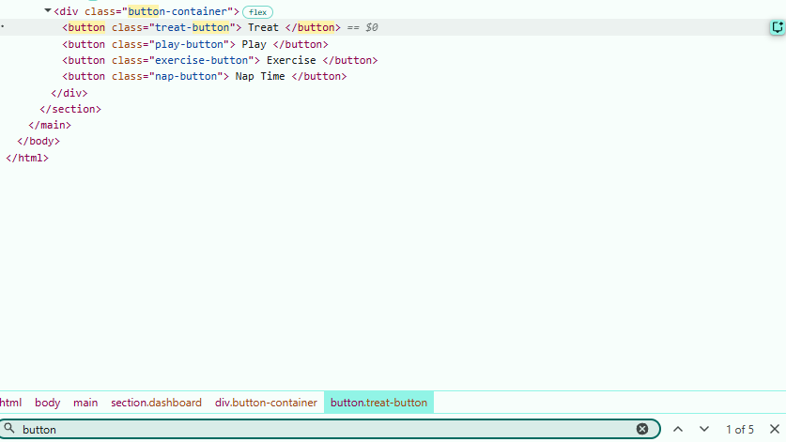
- here I use the search function to find the button class
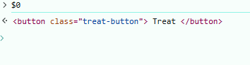
- here I searched for the $0 value in the console to look for what would populate
- Here I edit the text in the dom
- Here I change the header of this text from <p> to <h3>

